**Week 15**

**\*\*Ideas for the week\*\***

* Look at how the speed of entanglement is affected by interactions (NN vs 1/^r^6 vs closer spacing vs super slow quench (staying in ground state) ).
* Study what it means for our system to thermalise / not thermalise. Take sum of ‘spins’. Comparing to quantum statistical mechanics.
* Being writing up the motivation behind the Hamiltonian. Include matrices and so on to show how it works – a lot of this can be included in an appendix. Will help make work clearer.
* Looking at the uniform sharp drops in entanglement.
* Entanglement growth for 00…00 state vs r0r..0r state. Now this is really interesting in the global case.

**\*\*Thermalisation and Quantum Statistical mechanics\*\***

In generic isolated systems, non-equilibrium dynamics is expect to

Decoherence between eigenstate lead to thermalisation

**5 atoms**

Initial 00000 (Global)

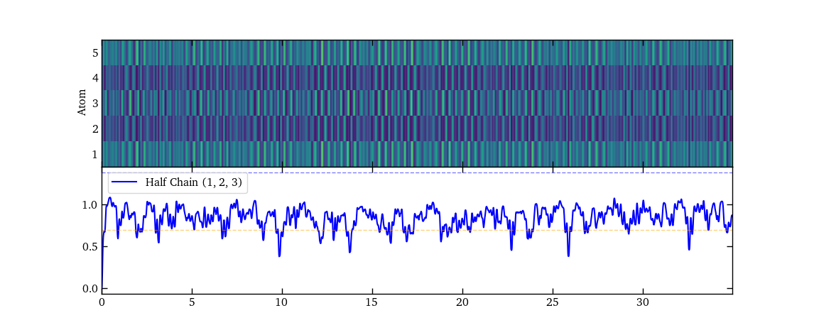

Initial r0r0r (Global)

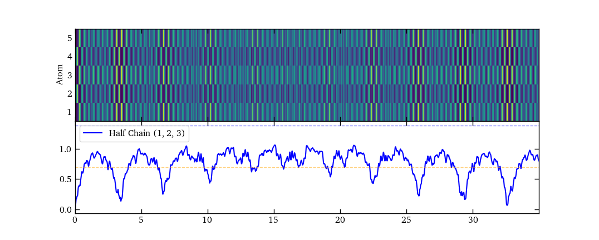

Initial r0r0r (local)

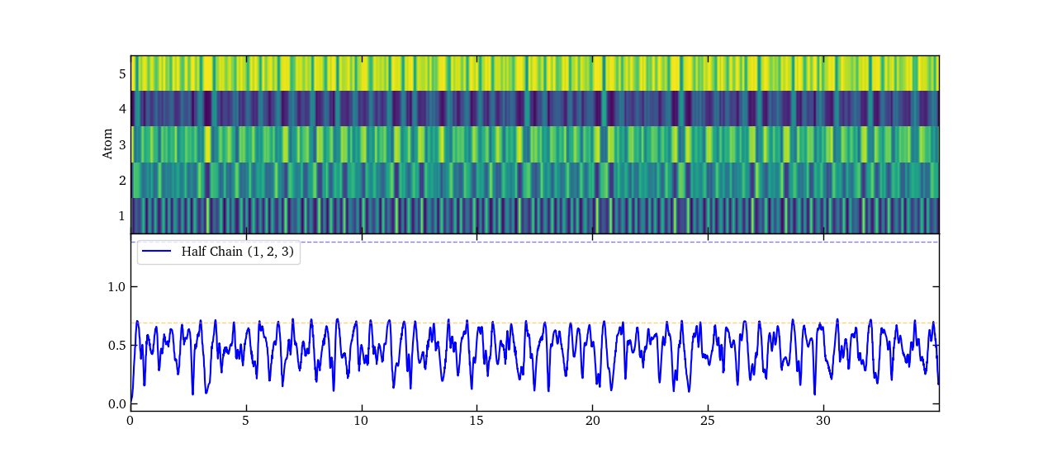

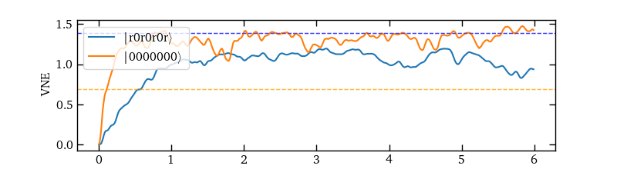**7 atom**

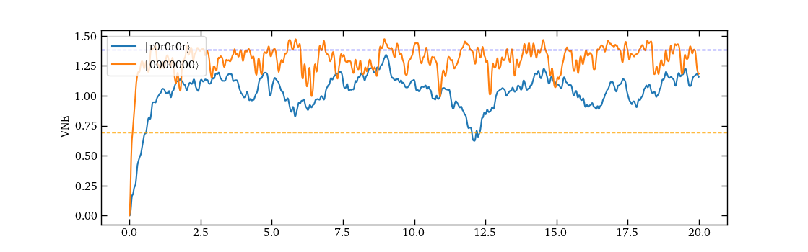

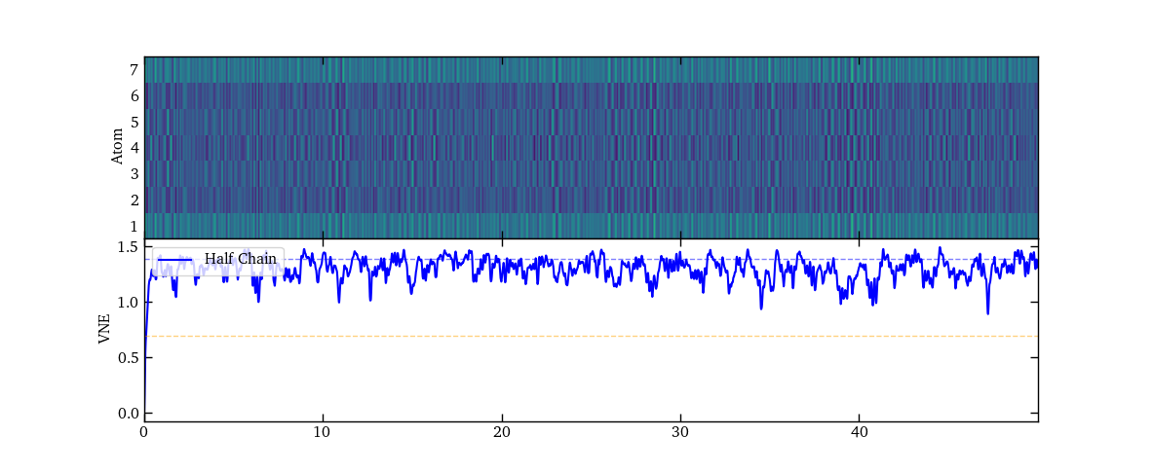

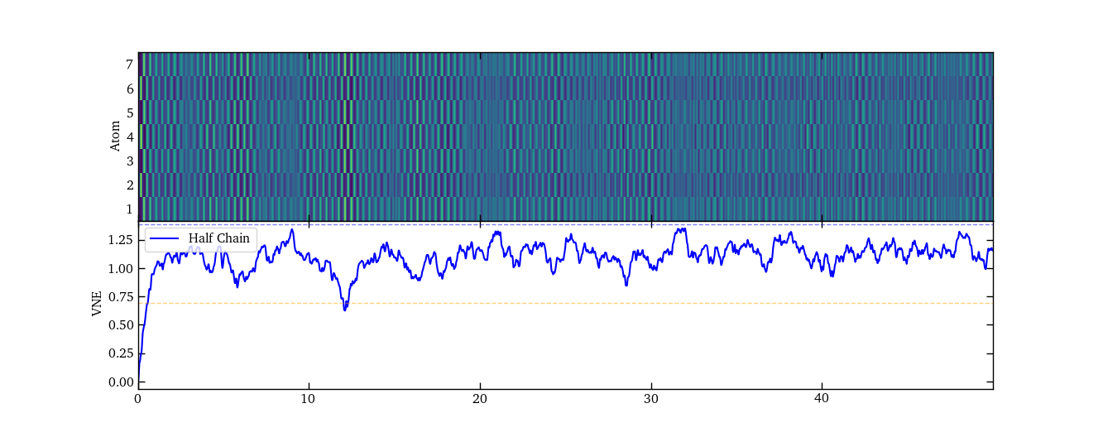

**Varying initial detuning (Speed kept at 3 GHz/microsecond)**

D_initial/2pi = 30 MHz, t_q = 0.01, dt =0.001



D_initial/2pi = 27 MHz, t_q = 0.009, dt =0.001



D_initial/2pi = 24 MHz, t_q = 0.008, dt =0.001



